The GIMP user interface is now available in two modes:

multi-window mode,

single window mode. (recommended)

When you open GIMP for the first time, it opens in multi-window mode by default. You can enable single-window mode through Windows → >Single-Window Mode) in the image menu bar. After quitting GIMP with this option enabled, GIMP will start in single-window mode next time.

Select Single Window Mode

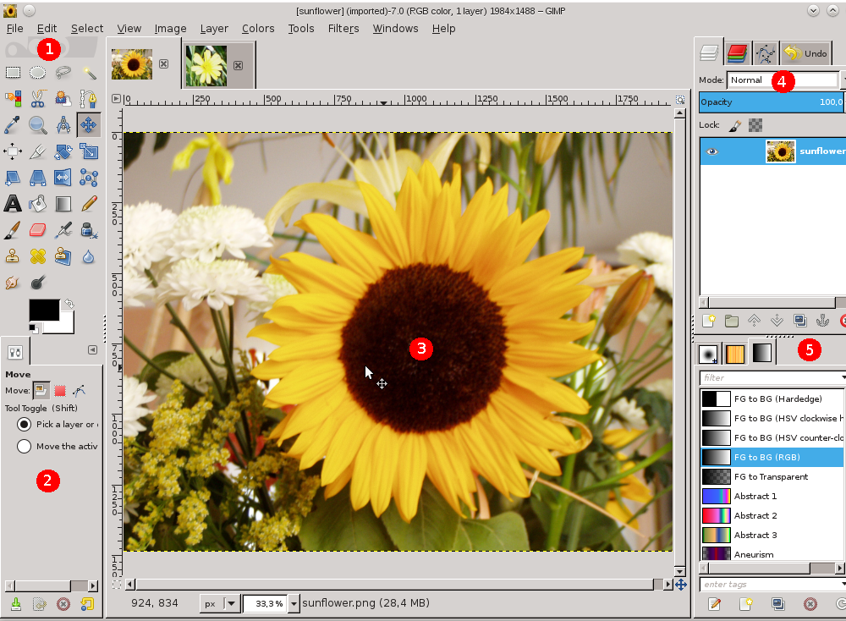

You find the same elements, with differences in their management:

* Left and right panels are fixed; you can't move them. But you can decrease or increase their width. If you reduce the width of a multi-tab dock, there may be not enough place for all tabs; then arrow-heads appear allowing you to scroll through tabs.

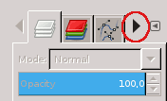

### 

### 

### 

### 2.1. The Toolbox

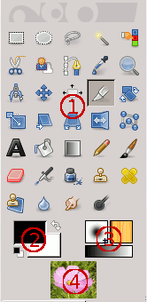

The Toolbox is the heart of GIMP. Here is a quick tour of what you will find there.

In the Toolbox, as in most parts of GIMP, moving the mouse over something and letting it rest for a moment, usually displays a «tooltip» that describes the thing. Short cut keys are also frequently shown in the tooltip. In many cases, you can hover the mouse over an item and press the F1 key to get help about the thing that is underneath the mouse.By default, only the Foreground-background icon is visible. You can add Brush-Pattern-Gradient icons and Active Image icon through Edit → Preferences →Toolbox:

1. Tool icons: These icons are buttons which activate tools for a wide variety of purposes: selecting parts of images, painting an image, transforming an image, etc. [Secció 1, «The Toolbox»](http://docs.gimp.org/ca/gimp-tools.html#gimp-toolbox) gives an overview of how to work with tools, and each tool is described systematically in the [Tools](http://docs.gimp.org/ca/gimp-tools.html) chapter.
2. Foreground/Background colors: The color areas here show you GIMP's current foreground and background colors, which come into play in many operations. Clicking on either one of them brings up a color selector dialog that allows you to change to a different color. Clicking on the double-headed arrow swaps the two colors, and clicking on the small symbol in the lower left corner resets them to black and white.
3. Brush/Pattern/Gradient: The symbols here show you GIMP'S current selections for: the Paintbrush, used by all tools that allow you to paint on the image («painting» includes operations like erasing and smudging, by the way); for the Pattern, which is used in filling selected areas of an image; and for the Gradient, which comes into play whenever an operation requires a smoothly varying range of colors. Clicking on any of these symbols brings up a dialog window that allows you to change it.
4. Active Image: In GIMP, you can work with many images at once, but at any given moment, only one image is the «active image». Here you find a small iconic representation of the active image. Click the icon to display a dialog with a list of the currently open images, click an image in the dialog to make it active. Usually, you click an image window in multi-window mode, or an image tab in single-window mode, to make it the active image.